Information Security 2 Final Test Review

Zero Conditional

Rewrite the following as zero conditional sentences

1. If you open this file, the virus will download

If you open this file, the virus downloads. (3인칭)

2. When a worm gets into your network, it will be hard to detect





Connect the events with cause-effect sentences

1. Click anywhere on the webpage

2. The malware downloads

3. Your computer crashes frequently

4. Data is lost

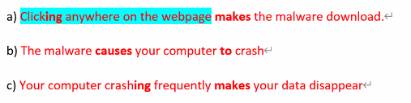

Past Continuous 

Answer the questions using the past continuous:

1. What were you doing last night?



2. Where was she studying last week?



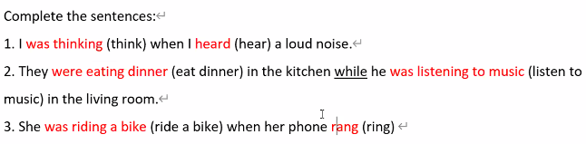

Rewrite the two events in one cause-effect sentence using “so… that…” or “such… that…”

Cause: I downloaded a big file / Effect: My computer crashed

I downloaded a so big file that my computer crashed.

Cause: The class was really interesting / Effect: I didn’t go to sleep

The class was so really interesting that I didn’t go to sleep.

Cause: There were many students / Effect: They made two classes

There were such many students that they made two classes.

